**ATC System**

**F28SD – Software Design**

**2nd March 2020**

**Hasan Kapadia**

**H00289018**

**F291-COS – BSc (Hons) Computer Science**

**Heriot watt University, Edinburgh**

Contents-

* **Introduction Statement**
* **Assumptions**
* **Functional Requirements**
* **Non-Functional Requirements**
* [**Use Case (Textual / Diagram)**](#_Use_Cases_()
* **Class-Responsibility-Collaborator Model**
* **Class Diagram**
* **Sequence Diagram**
* **Activity Diagram**
* **State Machine Diagram**
* **Statement**

# **Introduction Statement :**

In the past there weren’t any solid systems the aviation industry could use to map out proper flight paths and predict the weather conditions with it being done manually with a high risk of human error, with only having radio contact with the pilot which would not provide factual data proved to be a great challenge.

But as technological advancements are being made new and better systems are being released to be used in the aviation industry which has greatly reduced the risks of flying as with these new equipment’s mapping out flight plans and predicting weather changes have become more accurate with only a slight error rate compared to the systems used in the past.

The system proposed below includes all the new technological advancements made in the air traffic control systems, with better flight mapping and predictions cutting down the rate of error even further, with communications being moved from paperback to electronic communications and ATC systems being subdivided into many different sub-systems making it more efficient.

# **Assumptions :**

|  |  |
| --- | --- |
| **Assumptions** | **Impact** |
| Control Zone Spans approximately 25 miles wide and 10 miles High | Control Zone might differ |
| Connection/Networking between ATC systems are stable | All process can be put on halt if connection between systems are disrupted |
| All pilot systems are working fine | All process can be put on halt if connection between systems are disrupted and information is not being sent to the different systems |
| APC should be able to detect if any errors in system or disruptions in the airport to allow enough time/space for the aircraft to be re-routed | If APC is unable to check if all the gates at the airport are free or if there Is no disruptions at the airport the aircraft will not be allotted enough time to re-route. |

# **Functional Requirements :**

1. APC must maintain safe separation between aircrafts
2. APC must guide aircraft to the runway
3. APC must keep relevant aircraft information in Electronic Flight Progress strips up to date.
4. APC must provide weather reports to the approaching aircrafts.
5. Flight Progress Strip (FPS) must be converted to (Electronic Flight Progress Strip) EFPS.
6. Primary mode of communication must be Command Messaging System (CMS).
7. CMS must use predefined message as a means of communication.
8. Radio and landlines would be used as a secondary mode of communications.
9. EFPS must be maintained by AIC and APC
10. EFPS must contain aircraft type, call sign, altitude and gate number
11. EFPS for inbound aircraft must contain Expected Time of Arrival (ETA) and Actual Time of Arrival (ATA)
12. EFPS for outbound aircraft must contain Expected Time of Departure (ETD) and Actual Time of Departure (ATD) and the rout information.
13. GMC must allocate aircraft to gates.
14. GMC must guide aircrafts to taxi.
15. EFPS under AIC system will be classified into *pending, active and archived.*
16. EFPS under APC system will be classified into *pending, active, archived, and holding.*
17. ATC must have Flight Plan Logging (FPL).
18. The names and license number of the pilots should be validated.
19. FPDB must store all the completed FP.
20. EFPS must be generated from FP and send to AIC.
21. AIC and GMC should collaborate for an aircraft to depart.
22. When an aircraft is airborne, AIC must record the ATD on the EFPS and instruct the pilot to contact ATCC.
23. AIC must send a copy of EFPS to the ATCC and archive the EFPS.
24. APC must take control of an aircraft inside the control zone.
25. APC must provide directional information to aircraft.
26. APC must provide aircraft with Weather Report (WR).
27. AIC must provide aircraft with gate number before touchdown.
28. APC must log altitude and airspeed instruction through the EFPS
29. AIC takes over control from APC when aircraft reaches final approach.
30. AIC must get the gate number from GMC.
31. AIC must log the gate number to EFPS.
32. AIC must advise pilots of their allocated gate.
33. AIC must archive the EFPS after completion.
34. WR must include wind speed, wind direction and visibility

# **Non-Functional Requirements :**

1. Secondary mode of communication should be radio for aircraft to controller and landline for controller to controller.
2. AIC and APC are presented with EFPS information via touch screen display
3. E-FPS information are change via scribe
4. FP should be archived to Flight Plan Database (FPDB)
5. Pilot information must be validated by Pilot Database (PDB)
6. WR should be sent to APC every 15 minutes
7. GMC should communicate with AIC for aircraft taxi
8. AIC must record the Actual Time of Departure (ATD) on the EFPS
9. FPL system will allow pilots to submit FP electronically
10. AIC must record the Actual Time of Arrival (ATA) on the EFPS
11. AIC should send a copy of EFPS to ATCC before archiving

# **Use Cases ( Diagram / Textual) :**

|  |
| --- |
| Use Case: *Generating EFPS* |
| ID: *1* |
| Goal: *Generating Electronic Flight Progress Strip (EFPS) for the aircraft.* |
| Primary actor: *Pilot* |
| Secondary actor(s): *Flight Plan Logging system, Air Controller (AIC), Ground Movements Controller (GMC), Pilot Database (PDB)* |
| Preconditions:   1. *Aircraft is not in the controlled airspace* |
| Post-conditions:   1. *EFPS is received by the AIC* 2. *Aircraft is ready for departure* |
| Main flow:   1. *Flight Plan Logging (FPL) system requests the details of the Flight Plan(FP)* 2. *Pilot enters the details of the Flight Plan in FPL* 3. *FPL requests for validation of Pilot name and license number* 4. *Pilot Database (PDB) receives the names and the license numbers* 5. *PDB validates the names and the license number* 6. *FPL receives confirmation from PDB* 7. *GMC sets the departure gate number in the FP* 8. *FP is completed and archived in Flight Plan Database.* 9. *EFPS is generated by the FPL System with access to Flight Plan details.* 10. *EFPS is sent to the AIC system* 11. *EFPS is set as pending in the AIC system.* |
| Alternative flows:  *5a. PDB fails to validate the names and the license number*   1. *FPL receives the rejection from PDB* 2. *FPL requests the Pilot to enter the details again.* 3. *Repeat from step 2* |

|  |
| --- |
| Use Case: *Aircraft Departure* |
| ID: *2* |
| Goal: *<Process for aircraft departure >* |
| Primary actor: *<Pilot>* |
| Secondary actor(s): *<AIC>,<GMC>,<ATCC>* |
| Preconditions:   1. *Departure gate is set by GMC* 2. *EFPS approved by AIC* |
| Post-conditions:   1. *Successfully departed* 2. EFPS Handed over to ATCC |
| Main flow:   1. Pilot uses CMS for communication 2. GMC uses CMS for communication 3. Pilot gets in contact with GMC 4. Pilot informs of readiness 5. *GMC gets in contact with AIC* 6. *GMC requests for pushback from AIC* 7. AIC confirms pushback 8. GMC allows the aircraft to taxi to holding point 9. AIC takes over direct control of the aircraft 10. Aircraft awaits departure slot 11. Departure slot arrives 12. AIC instructs pilot to taxi 13. Pilot taxis and awaits final clearance. 14. Final clearance is given for take-off 15. Aircraft is airborne 16. Once airborne the AIC records the ATD on the EFPS 17. AIC requests the pilot to contact ATCC 18. AIC sends EFPS to ATCC 19. AIC marks (EFPS) as archive. |
| Alternative flows:  *<4.a> <Pilot not ready>*   1. *GMC awaits pilot’s response on readiness* 2. *All processes are put on hold until pilot confirms readiness* 3. *Once readiness confirmed return to step 5*     *<6.a> <AIC denies Pushback>*   1. *Departure slot pushed back* 2. *Pilot awaits at gate until AIC confirms pushback* 3. *Once AIC confirms pushback return to step 7*   *<11.a> <Final clearance denied>*   1. *Pilot awaits at the end of the runway until final clearance given* 2. *Once clearance received return to Step 14* |

|  |
| --- |
| Use Case: *Handover Control* |
| ID: *3* |
| Goal: *ATCC handovers control to APC* |
| Primary actor: *ATCC* |
| Secondary actor(s): *Pilot* |
| Preconditions:   1. *An aircraft approaches the control zone* |
| Post-conditions:   1. *APC takes control of the aircraft.* 2. *Pilot contacts the APC* |
| Main flow:   1. *ATCC controller sends EFPS and alerts APC about the aircraft* 2. *EFPS is set as pending* 3. *APC receives the EFPS and sends a confirmation to ATCC* 4. *ATCC controller instructs the pilot to contact APC* 5. *Pilot receives the instruction* |
| Alternative flows:  *3a. ATCC does not receive confirmation.*   1. *Repeat step 1 in the main flow* 2. *Return to step 3* |

|  |
| --- |
| Use Case: Reaches *Control Zone* |
| ID: *4* |
| Goal: *Guiding pilot to the runway and send relevant information* |
| Primary actor: *Pilot* |
| Secondary actor(s): *Weather Station (WS)* |
| Preconditions:   1. *Aircraft approaches the control zone.* 2. *ATCC handovers the control to APC.* 3. *Pilot is instructed to contact APC.* |
| Post-conditions:   1. *AIC takes over the control* 2. *Pilot contacts AIC* |
| Main flow:   1. *Pilot contacts the APC for flight information.* 2. *APC receives contact and provides directional information to the pilot.* 3. *Pilot follows the glide path to the runway using the directional information.* 4. *Aircraft enters the Control Zone (CZ).* 5. *APC receives Weather Report (WR).* 6. *APC sends the WR to the aircraft’s on-board computer.* 7. *APC sends altitude and airspeed instruction on the EFPS periodically.* 8. *Pilot receives the instruction from the EFPS periodically.* 9. *Pilot reaches final approach.* 10. *APC passes control to AIC.* |
| Alternative flows:  *10a. APC cannot pass the control to AIC because Control Zone is busy.*   1. *APC routes the aircraft to a holding stack* 2. *APC waits until landing slot is available* 3. *When a landing slot is available, AIC passes control to AIC*   *5a. WR changed*   1. *APC sends the updated WR* |

|  |
| --- |
| Use Case: Land Aircraft |
| ID: *5* |
| Goal: *Guiding pilot to the runway and send relevant information* |
| Primary actor: *Pilot* |
| Secondary actor(s): *ATCC* |
| Preconditions:   1. *Aircraft reaches the final approach* 2. *APC handovers the control to AIC.* 3. *Pilot is instructed to contact AIC.* |
| Post-conditions:   1. *Aircraft reaches their allocated gate.* 2. *Inbound process is complete.* |
| Main flow:   1. *Pilot gets in contact with AIC.* 2. *AIC requests a gate number from GMC.* 3. *GMC provides the gate number to AIC* 4. *AIC logs the provided gate number on the EFPS.* 5. *Aircraft touches down* 6. *AIC records Actual Time of Arrival (ATA) and logs it into EFPS.* 7. *AIC advises the pilots of their allocated gate.* 8. *AIC completes the EFPS and is archived* |
| Alternative flows:  *5a. Aircraft takes too long to touch down.*   1. *AIC instruct the pilot to overshoot.* 2. *AIC handovers the control to APC.* 3. *APC gives directional information to glide path for a second attempt.* 4. *Return to step 5 in main flow.*   *5a3b. Airport is busy*   1. *APC places the aircraft to a holding stack.* 2. *APC waits until a departure slot is available.* 3. *APC gives directional information to glide path.* 4. *Return to step 5 in main flow.* |

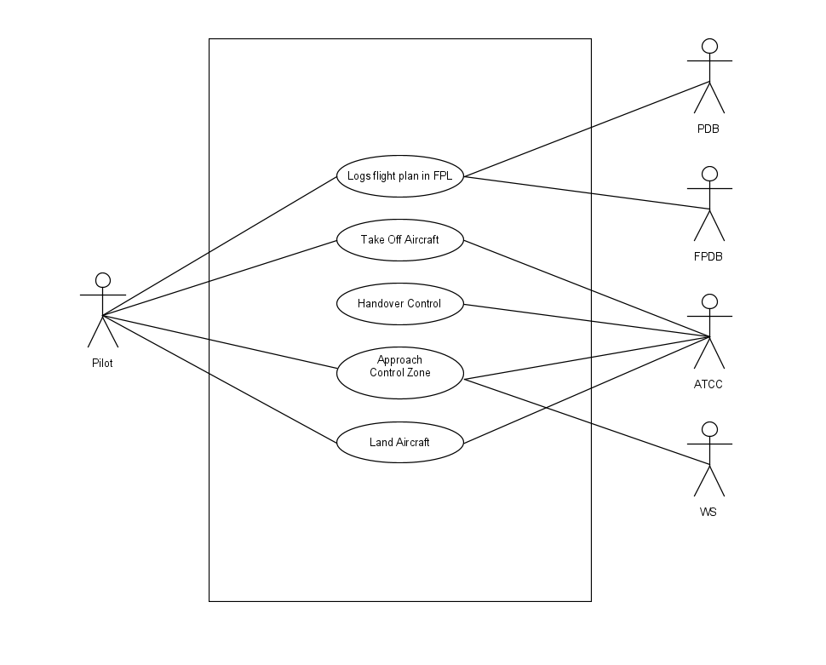

# **CRC Model :**

|  |  |
| --- | --- |
| **Class:** AIC | |
| **Responsibilities:** | **Collaborators:** |
| **Departure Slot Requested** | **GMC** |
| **AIC takes over control of aircraft** | **Pilot** |
| **Requests Gate Number** | **GMC** |
| **If overshoot hands over control of aircraft** | **APC** |
| **Allow aircraft pushback** | **GMC** |
| **Instruct Pilot to taxi at runway** | **Pilot** |
| **Records ATD on eFPS** |  |
| **Sends eFPS to ATCC** | **ATCC** |
| **Archives eFPS** |  |
| **Logs ATA** |  |
| **Take-off clearance given** | **Pilot** |
| **Maintains eFPS** | **APC** |
| **Receives control of Aircraft** | **APC** |
|  |  |

|  |  |
| --- | --- |
| **Class:** GMC | |
| **Responsibilities:** | **Collaborators:** |
| **Departure gate Allotted** | **AIC** |
| **Allots gate number for touchdown** | **AIC** |
|  |  |
|  |  |
|  |  |

|  |  |
| --- | --- |
| **Class:** APC | |
| **Responsibilities:** | **Collaborators:** |
| **Maintains eFPS** | **AIC** |
| **Aircraft eFPS received** | **ATCC** |
| **Contact established with aircraft** | **CMS** |
| **Provides directional information** | **Pilot** |
| **Provide Weather report** | **Pilot** |
| **Altitude and airspeed instructions logged** |  |
| **Passes aircraft control** | **AIC** |
| **Receives weather report** | **WS** |
| **If error occurred re-route aircraft** | **Pilot** |
|  |  |

# **Class Diagrams :**

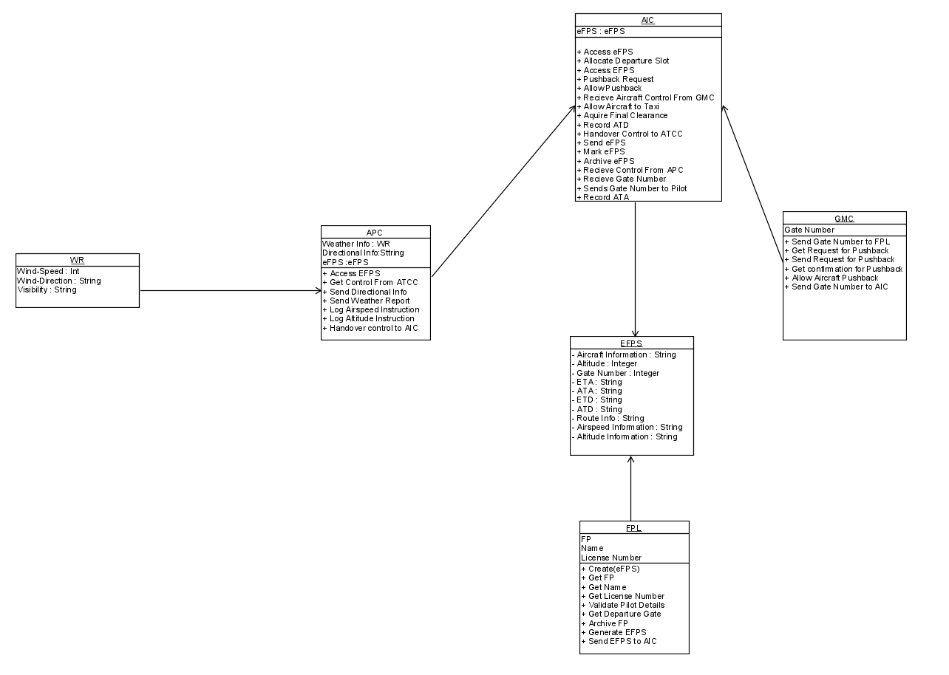

# **Sequence Diagram :**

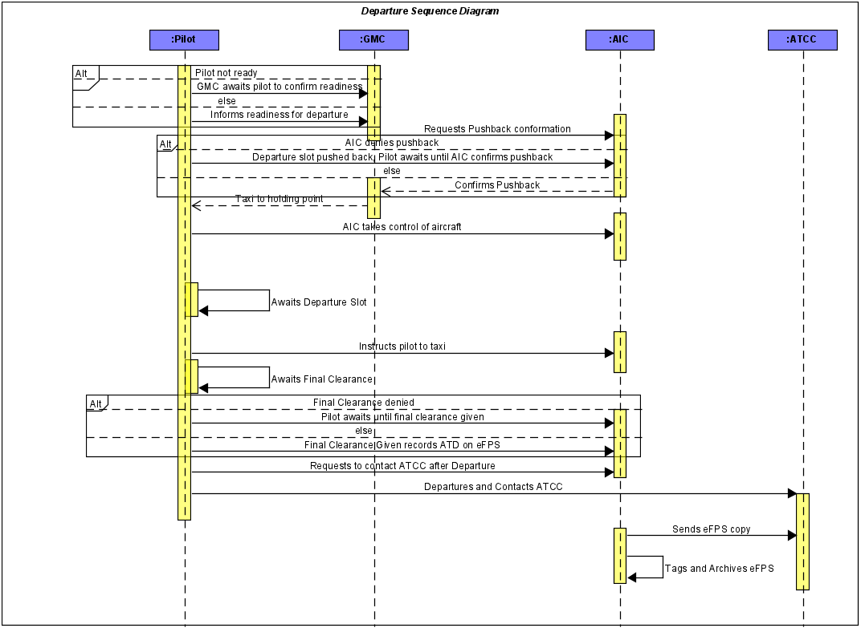

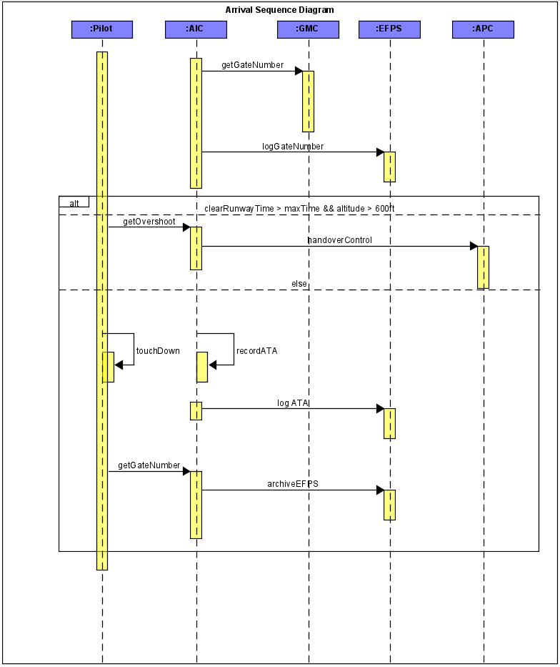

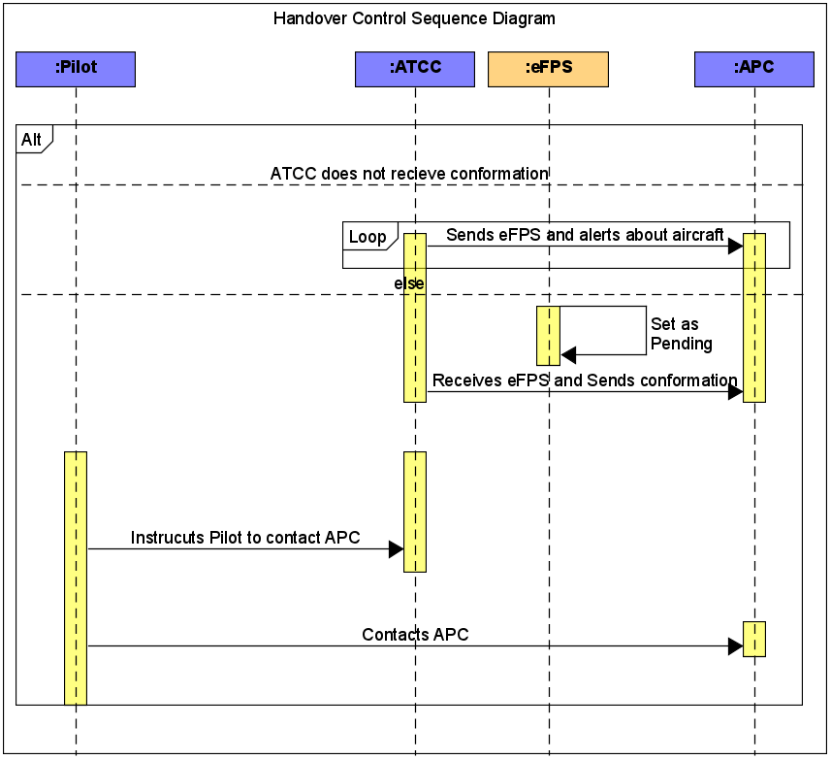

# **Activity Diagram :**

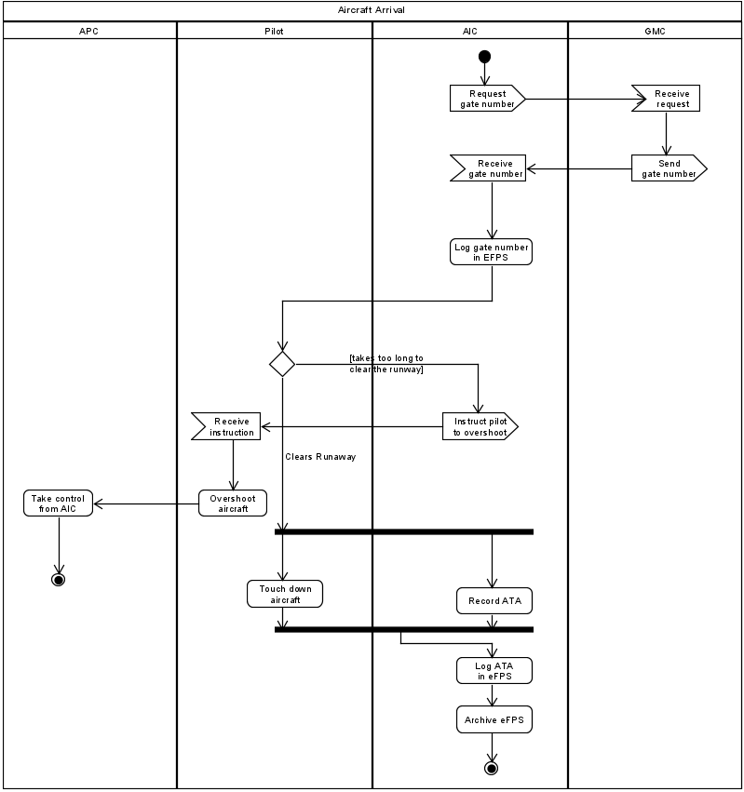

# **State Diagram :**

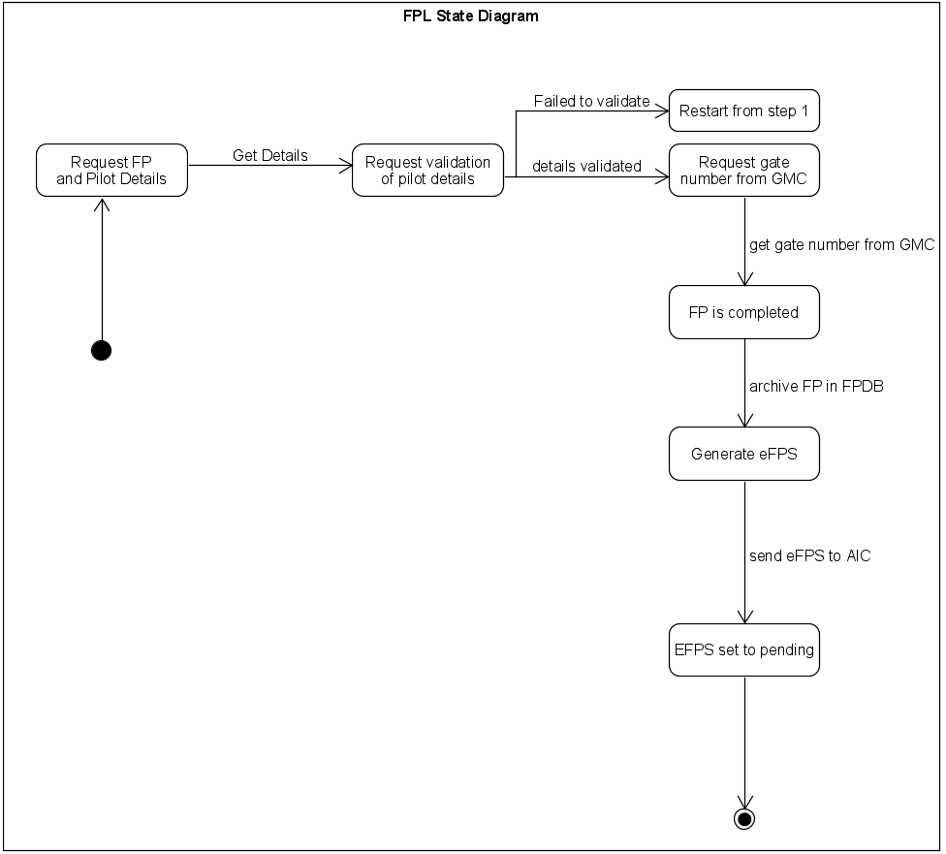

# **Statement :**

Making the ATC systems using UML in the start proved to be a great challenge with UML having a multitude of functions to use. After using UML for this course, it showed to have quite a few strength and weaknesses as shown below:

**Strengths:**

* **Easy to understand user interactions/interface**
* **Easy to use sketching/blueprinting modes**
* **Abundance of tools to use in UML**

**Weakness:**

* **Complex to use**
* **Might be difficult for customers to understand complex UML diagrams**

**END**

**P.S-**